**DAILY ONLINE ACTIVITIES SUMMARY**

|  |  |  |  |  |  |  |  |
| --- | --- | --- | --- | --- | --- | --- | --- |
| **Date:** | **08-07-2020** | | | | **Name:** | **B.A.SOHANKUMAR** | |
| **Sem & Sec** | **4th SEM A** | | | | **USN:** | **4AL18CS013** | |
| **Descriptive Test Summary** | | | | | | | |
| **Subject** | | **DESIGN AND ANALYSIS OF ALGORITHM** | | | | | |
| **Max. Marks** | | **100** | | **Score** | | **Not yet declared** | |
| **Certification Course Summary** | | | | | | | |
| **Course** | **SPARK BASICS AND STREAMING** | | | | | | |
| **Certificate Provider** | | | **GLA** | **Duration** | | | **7 HOURS** |
| **Coding Challenges** | | | | | | | |
| **Problem Statement:1:Write a java program to find whether the given strings are anagram** | | | | | | | |
| **Status :EXECUTED** | | | | | | | |
| **Uploaded the report in Github** | | | | **YES** | | | |
| **If yes Repository name** | | | | **https://github.com/sohannaik5648987/DAILY-REPORTS** | | | |
| **Uploaded the report in slack** | | | | **YES** | | | |

ONLINE DESCRIPTIVE TEST:

Today.there was test on DESIGN AND ANALYSIS OF ALGORITHM for 100 marks.The duration of the test was 45 minutes.Three questions were give and it was like we have to write the answers in paper and upload to Google classroom.

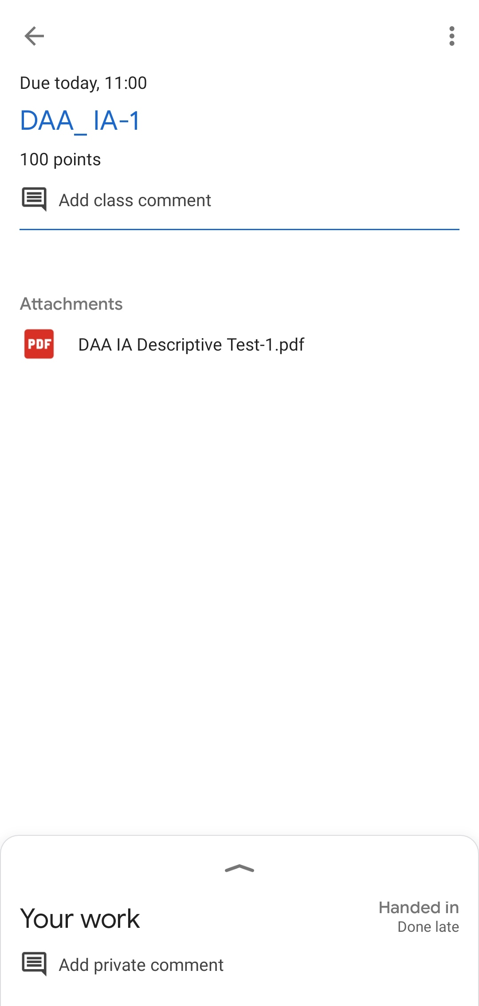

CERTIFICATION COURSE DETAILS:

Course:Spark basics and streaming

Today I have opted this new course and this course has a video content of 7hours and one assessment quiz.Completed modules today are Getting started - Spark Basics,Spark and Hadoop - Face to Face,Spark - Architecture,RDDs - Building blocks of Spark,RDDs continued,Spark Fundamentals Quiz,Spark Terminologies,Pyspark - Getting hands dirty,Spark - MLlib.

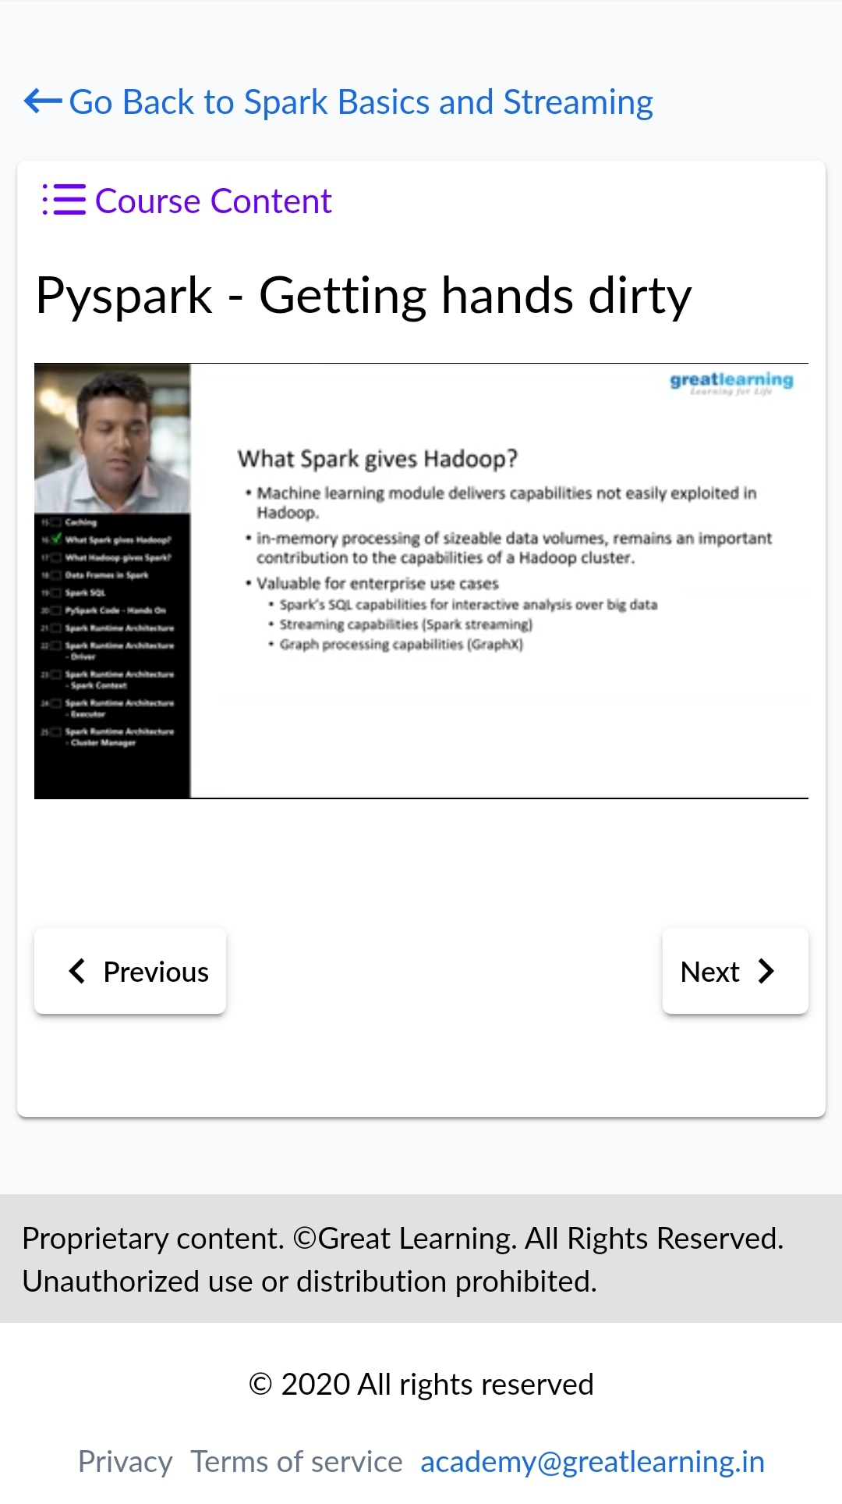 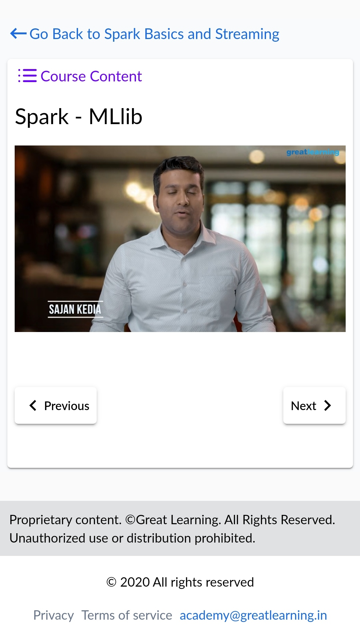

CODING CHALLENGES DETAILS:

1.Write a java program to find whether the given strings are anagram.Given two strings a and b consisting of lowercase characters. The task is to check whether two given strings are anagram of each other or not. An anagram of a string is another string that contains same characters, only the order of characters can be different. For example, “act” and “tac” are anagram of each other.

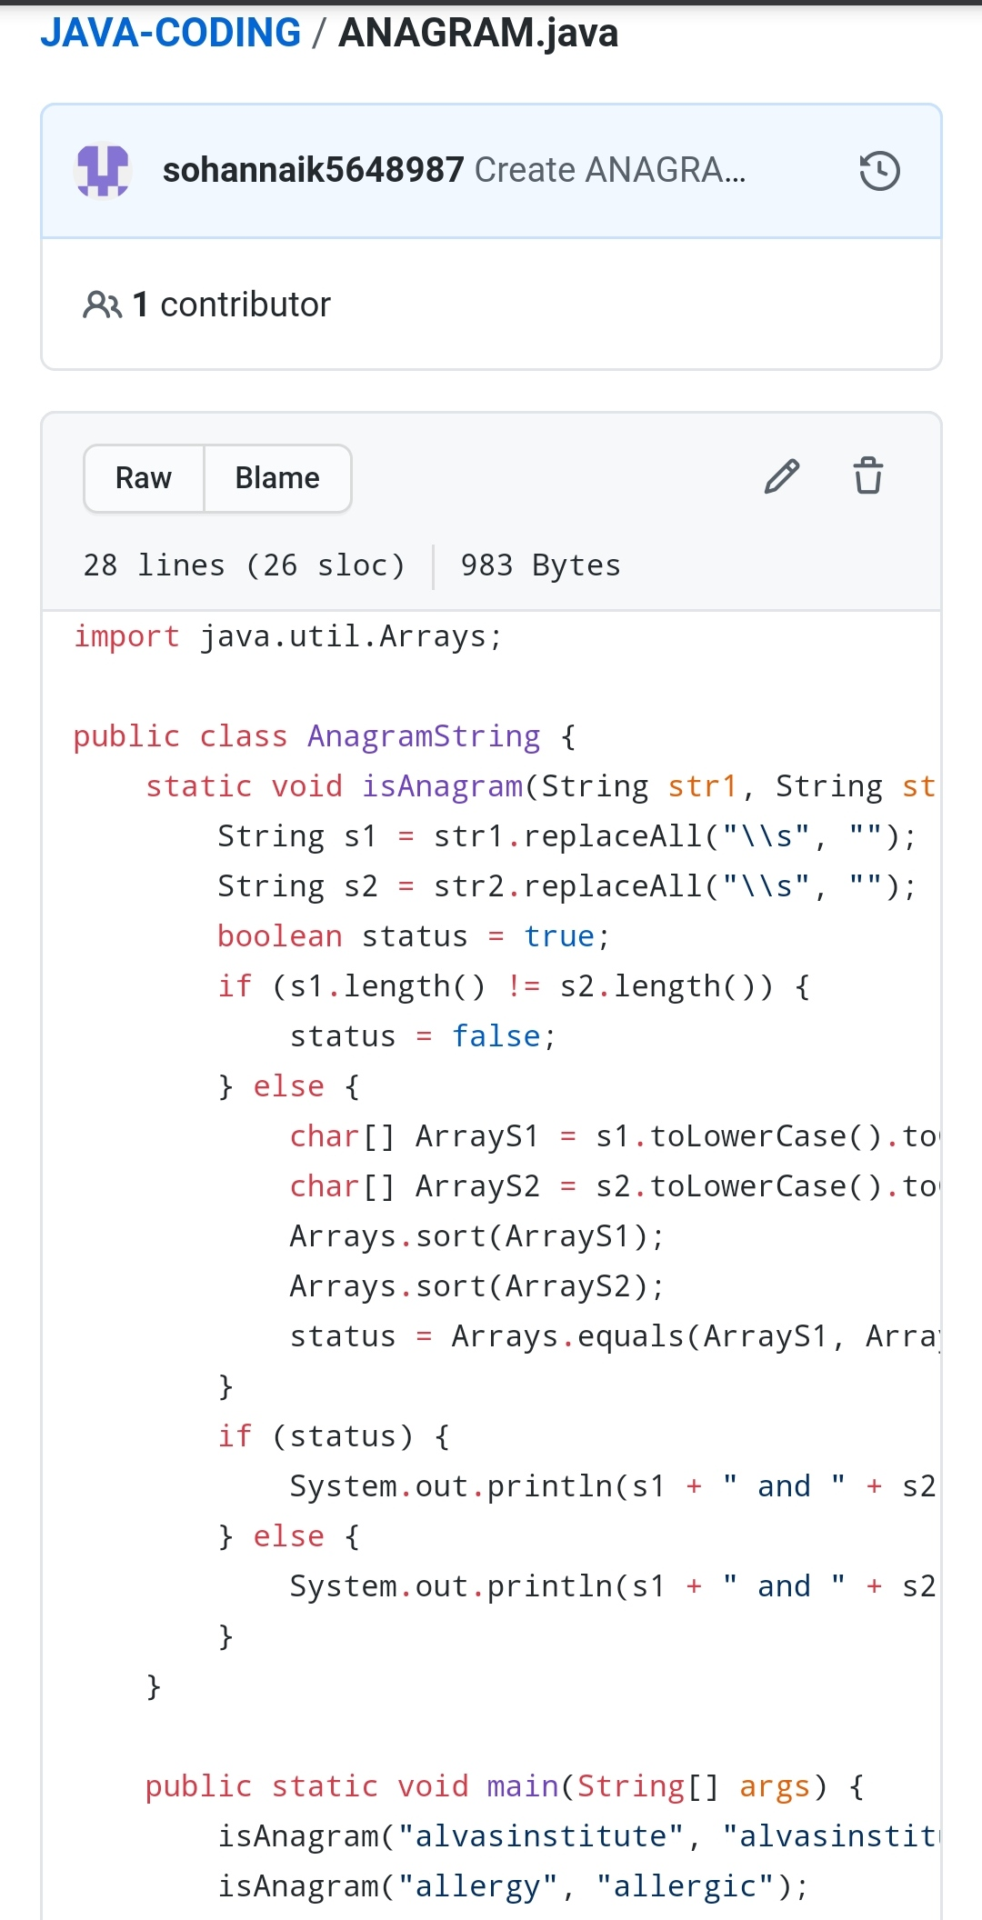

REPOSITORY LINK:https://github.com/sohannaik5648987/JAVA-CODING